Life Savers  
  
Not just another day at the beach

Contents

**Overview** 2

**Product Details** 2

*Players* 2

*Genre* 2

*Platform* 2

*Outlets* 2

**Summary** 2

**Pillars** 2

**Revision History**

|  |  |  |
| --- | --- | --- |
| **Version** | **Date** | **Details** |
| 0.1 | 23.04.2021 | Initial Document |
|  |  |  |
|  |  |  |
|  |  |  |
|  |  |  |
|  |  |  |
|  |  |  |

# Product Overview

## 

## **One Line Summary**

Saving lives on the beach of Bondi takes more than just stamina

## **Description**

*Life Savers* is a life management sim, where you manage the mental health and stamina of your life saving team in Bondi Beach Life Savers Club.

**Details**

* Players: Single Player
* Genre: Management style game / Isometric
* Platform: PC

## **Unique Selling Points**

* A closer look at the inner workings of the Lifesaving volunteers of Australia
* Beach culture aesthetics
* Diorama art style

## **Target Market**

* Casual players
* Players that enjoy a level of micromanagement

## **Design Pillars**

* Emotional, Physical and Mental Stress management
  + Focusing on the welfare of your life saving team and managing each unique character’s strengths and weakness to use them in the appropriate scenario
* State Management
  + Characters will adopt states which allow them to patrol and react to situations depending on their states (stressed, determined, energetic, etc.)

**Game Loop**

Patrolling section of the game loop feels a bit off with the way it asks whether it’s a task or situation, only for the branches to immediately converge before going back out. Assigning the task first and then having the loop ask if it is a task or situation would make more sense in the flowchart. Having something to signify the game looping back after a shift would also be helpful.

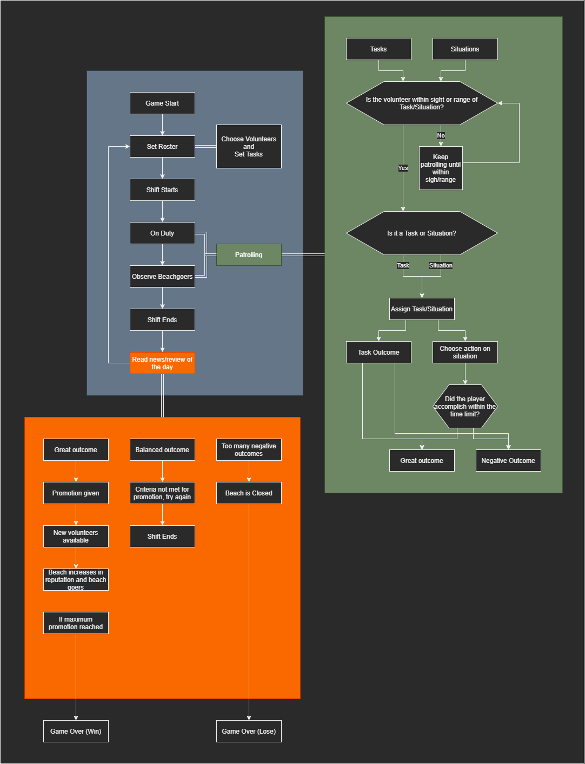

# **Mechanics and Systems**

* Movement & Camera
  + Scene transitions between areas (beach, roster, office, sea/ocean)
  + Movements are scripted to demonstrate outcomes of the states of the characters
  + Movement explanation feels a bit vague to me, how exactly will the player be moving? What type of control? Stuff like that
* Notifications
  + Notifications occur if there are moment that players need to address, from stressed (breakdown moments) to situations happening at the oceans (drowning, altercations)
  + Will notifications purely be for telling the player something that’s happening? Or will the player be able to act directly from the notification interface?
* Menu
  + Simple menu system that allows play, pause, sound control
* Roster
  + Players ability to assign and change the roster of the volunteers that work, whether they need a break and be replaced by someone fresh, or to assign a task to a well skilled volunteer
* State System
  + Idle, Patrolling, or performing a task, this will be dependant on the circumstances and events of the team members and will dictate their actions as a result
* Equipment usage system
  + Team members can use the available equipment (buggy, life saving board) to better manage their Stamina and mental health meters if available
* None of these dot points really touch upon aspects of the game such as what is meant by the workers’ mental health or what makes them need to take a break etc. Similarly, there’s not really anything about the tasks themselves here, only the notification system, roster and other systems surrounding this central task system/mechanic. While some of these have aspects that could fall under economies, they should still be at least mentioned in the mechanics and systems part of the document.

# **Controls**

* PC
  + Mostly mouse controls to react to notifications and drag and drop volunteers into a proper position for the roster

# **Key Characters**

* Manager
  + The player, who manages the roster and assigns volunteers the tasks
* The Volunteers
  + 5 Volunteers to manage, each with their own personalities
  + Provide a brief example of a couple of personalities (a line’s worth between the 2) to provide a bit more of an idea about what to expect from these different personalities.

**Player Progression**

* At the passing of each day/week, a report comes up with reviews of the volunteer’s morale.
* There are news of any incidents and reflect how positively or negatively dealt with depending on players choices
* Touch more upon how the players progresses in relation to these points, what ramifications does morale and incidences have on player progression in particular?

**Level Design**

Simple Environment of a shot of the beach, a shot of an office and an image of a roster

* Bondi Beach
  + The level is a shot of Bondi Beach in which the volunteers act and react to what happens there
* Office
  + The are in which the player can decide what to organise, from the roster to the equipment allocation and crew evaluation, review and reports to make an informed decision as to how the volunteers will work

**Themes and Story**

It is the first day of managing a volunteer life saver club at Bondi, the themes are beach, sunny days for the most part, patrons at risk of drowning, or curbing poor behaviour, like litter and graffiti etc.

Also touch upon the more abstract themes of the game rather than just those relating to the game’s aesthetic. This is an ideal time to tie back a bit more to the moral argument of the game and explain how the different aspects of it tie back to the central theme of lifesaving taking more than just stamina.

**The Story**

The story is the player is hired to manage the volunteer crew and maintain a good working environment that takes care of the welfare, physically and mentally of each of the unique members.

**Art Style and Aesthetic**

* Colour Palette

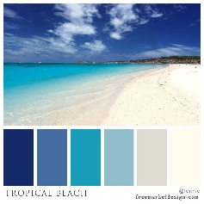

* Character Art Style

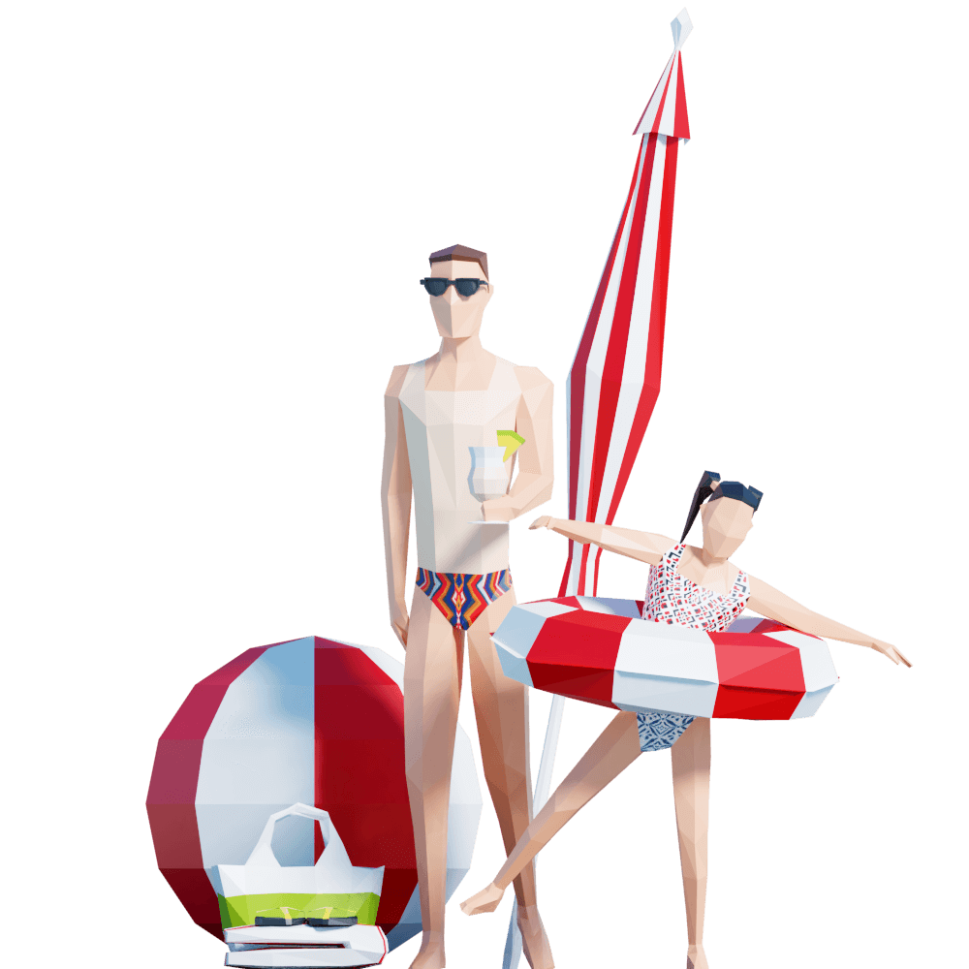

* Environmental Art Style

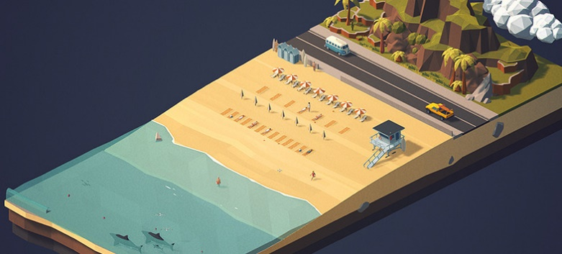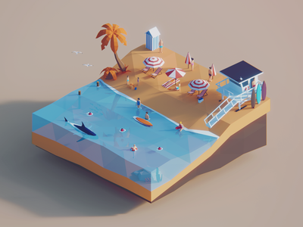

* Lighting

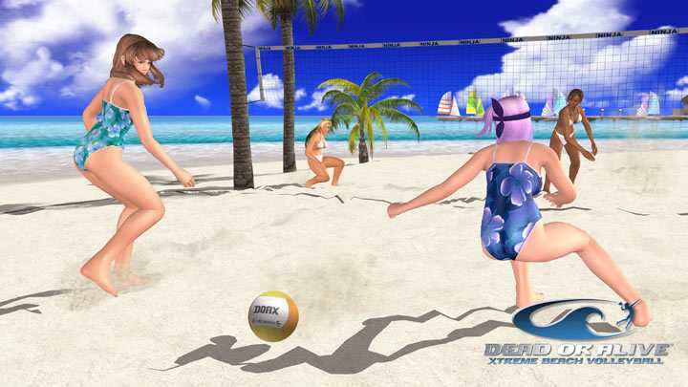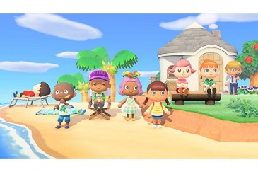

**Sound**

* Music (Music will change depending on the mode (Office/Beach) and circumstances (Chill no events / Hectic dramatic action)
  + Chiptunes style of music (Synthwave, Retro Chill)
    - Highway Superstar – Skylines
    - Slumber – Qwerty Woman
    - City Limits – Lakey Inspired
  + Chillout Lounge Style as an alternative
* SFX
  + Beach Waves
  + Crowd sound
  + Water
  + Running
  + Paper Rustling (Roster)
  + Click/Typing sounds (emulating using a computer to set tasks)
  + Crowd yells (when a shark is spotted or drowning)
  + Emergency Alarm